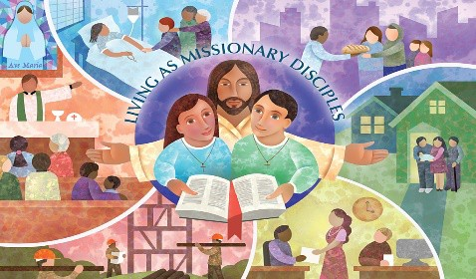
LIVING FAITH

SOLEMNITY OF THE ASCENSION OF THE LORD MAY 17, 2026

World Communications Day
Matthew 28:16-20
Now the eleven disciples went to Galilee, to the mountain to which Jesus had directed
them. When they saw him, they worshipped him; but some doubted. And Jesus came and said to them, ‘All authority in heaven and on earth has been given to me. Go therefore and make disciples of all nations, baptizing them in the name of the Father and of the Son and of the Holy Spirit, and teaching them to obey everything that I have commanded you. And remember, I am with you always, to the end of the age.’

GOSPEL REFLECTION
Every time this solemnity comes around, imagine the disciples standing and looking up into heaven as Jesus leaves, and then lowering their heads, looking around at one another and someone murmurs, “Now what?”
The Ascension marks a definitive moment for the apostles and disciples of Jesus. Jesus has left them post-resurrection. They now have to figure out how they are going to live their lives in light of the life, death and resurrection of Jesus.
Like the early Church, we now possess the mandate to go and baptize, teach and remember that Jesus is with us just as much today as he was back in their day. Our time is radically different than the disciple’s times. And yet, our faith remains the same: we care called to proclaim a Gospel of life and of repentance which bring a fresh start. We are called to proclaim a Gospel that says the poor, the marginalized, the estranged all matter in God’s eyes. Jesus came with a particular love for them. Now it is us who have to consider who fills the ranks of these groups today. Now it is our task to discover how can we preach the Gospel in a way that is relevant, welcoming and open to the people of our time. This is both a challenge and an opportunity. These times call for a different approach; as the Redemptorist saint Clement Hofbauer once said, “preach the Gospel ever anew”. What are some of these new ways? Well, we are called to be humble, to respect differences, to speak our truth with authenticity, but do so in way that respects the diversity of our time, and to engage with those beyond our walls.

WHAT ABOUT US?
- How can you proclaim the Gospel in your own situation?
- Who needs to hear the Gospel proclaimed today as Good News for them?
- What are some of the ways you can think of that this can be accompalished?

© 2026 Roman Catholic Archdiocese of St. John's
www.rcsj.org

Solemnity of the Ascension
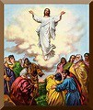

Trace a path to Jesus
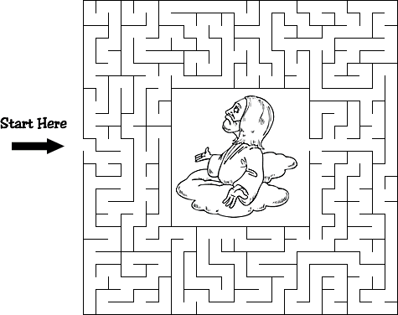

Subscribe to our weekly Catechetical Resource. E-mail: Familycatechesis@rcsj.org

World Communications Day May 17

Today Catholics are invited to reflect upon the media of social communications (films, radio, newspapers, audiovisuals) and how these influence our lives.

The media can promote values that lead to a more fully human society. The Church's ministry is twofold. The media can be used to help promote the Gospel. At the same time, as receivers of the materials presented by the media, the faithful have a duty to support and promote worthwhile presentations on media and reject those which promote values contrary to spiritual growth.
From Ordo Liturcical Calendar 2025-2026

The theme for World Communications Day this year is Preserving Human Voices and Faces. Click here to view Pope Leo's message for this year.
Last year the Canadian Conference of Catholic Bishops issued a Pastoral Use of Social Media. This letter and attendant resources can be found here.

Next Sunday, May 24, is Pentecost Sunday


Take some time this week to reflect on the Gospel for Pentecost Sunday: John 20. 19-23



Prayer for National Family and Life Week May 10 – 17, 2026 “I am with you always”.
Good and gracious God,
In you we place our trust, mindful of your constant presence and loving care.
Through your goodness we have received life and the joy of living in relationship with one another.
Guide our families during all stages of life to seek your strength and comfort.
As we navigate the daily tasks of family life, may we call on your Spirit to lead and inspire us.
Knowing the constant love you have for us, may we offer praise and thanks to you.
Through our Lord Jesus Christ, your Son,
who lives and reigns with you in the unity of the Holy Spirit, God for ever and ever.
Amen

Annual Celebration of Marriage and Family Life
On Sunday June 14, at 3:00 p.m., the Archdiocese will be hosting our annual Mass celebrating the Sacrament of Marriage and the gift of Family Life at the Cathedral-Basilica of St. John the Baptist. All are welcome and invited to attend this celebration. Couples married in the Catholic Church who register by June 8th will be officially acknowledged at the Mass and receive a special blessing as part of this celebration. A registration form can be found on the Archdiocesan webpage (www.rcsj.org), or registration can be taken by phoning the Archdiocesan Office of Evangelization and Catechesis at 709-726-3660 ext. 2. (For those unable to attend, the Mass will be live streamed at Cathedral Basilica Foundation - YouTube. A reception will follow Mass at the Cathedral.
Horizons of Hope
Horizons of Hope is a four week series that combines good video input from experts, helpful print resources and guided small group discussion. The series helps us to explore some of the questions that people often ask about care of people at the end of life’s journey:
- How do we make good decisions when faced with life-limiting illnesses?
– How can we accompany and support those who are sick and dying?
- How might we make choices for compassionate care at the end of life?
- How does our faith in Christ help us to understand the human experience of dying and death?

Horizon of Hope will be offered on Thursday nights in May (May 7, 14, 21, & 28 from 7-9 pm) at St.
Teresa’s church, 120 Mundy Pond Rd. Registration is free, but required. To register, contact rafftcssr@gmail.com

